Hasan Hashim

9/29/2020

Systems Fundamentals - Process Lab: Accessing Data in Memory

1. Take a screenshot that show the Firefox process in list. Annotate this screenshot to highlight the Firefox process’s memory address.



1. How many handles are open for Firefox?

189

1. What is the Process ID for Firefox?

276.

1. Take a screenshot of the full path to the Firefox program, and annotate it to highlight this path.

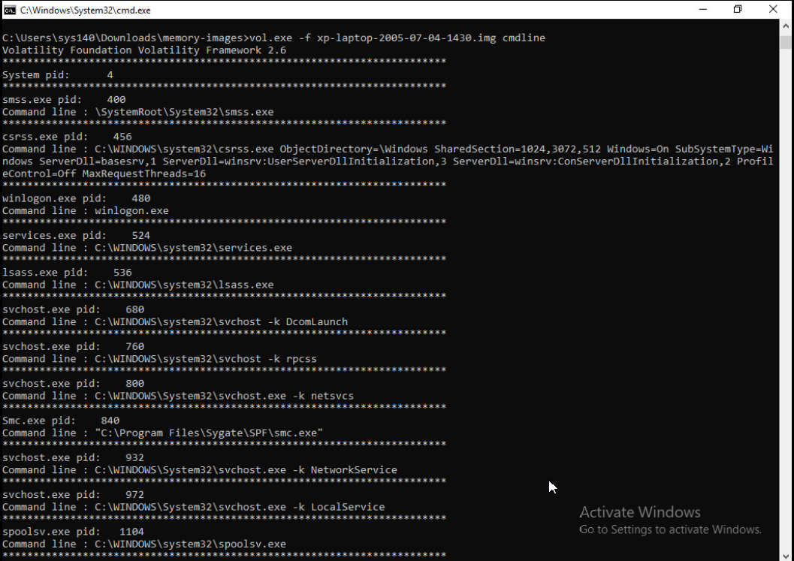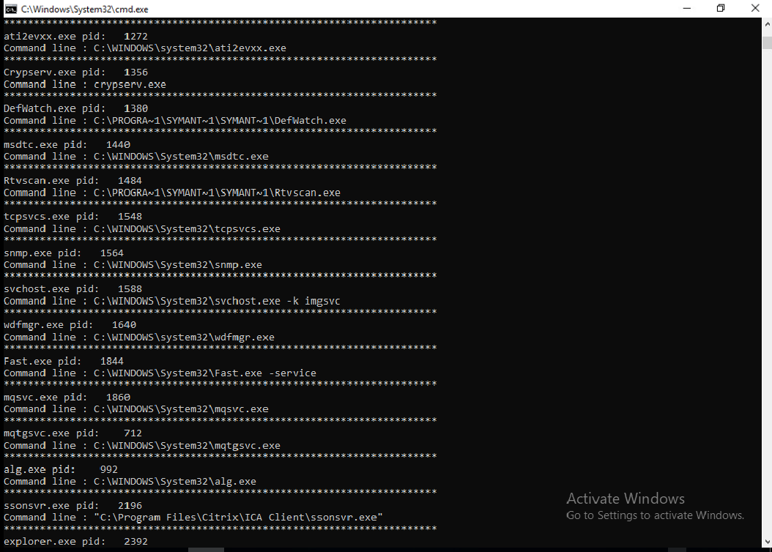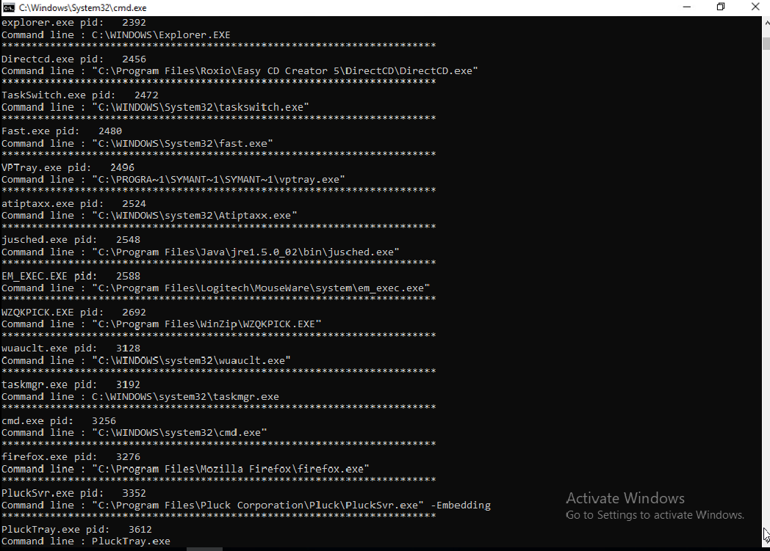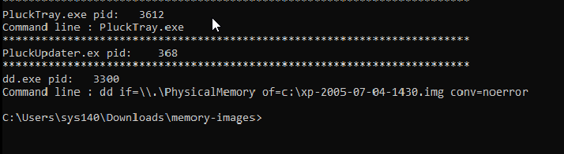

1. Take a screenshot of the hashes, and annotate it to highlight the hash for the user Sarah.

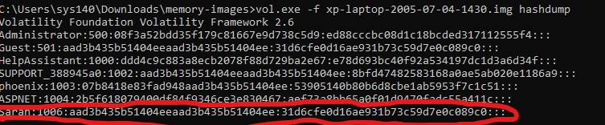

1. Take a screenshot of the directory contents, and annotate it to highlight the file that was extracted. It should be the same size as the file in the above screenshot that starts with executable.XXXX.exe. The XXXX will be the process ID.

